**QUESTION**

Create a employee table in Mysql and columns as Emp_id, Emp_name, Dept_name(Hadoop Developer), Emp_sal.

● Import the employee table contents into the HDFS directory using Sqoop.

● Create a employee2 table in Mysql and Export Top 5 employee details Emp_name and Emp_sal from HDFS directory to Mysql table employee2 using Sqoop.

● Explain the procedures performed, Share the screenshots of commands and results for the same.

**ANSWER**

Creating a table named employee and inserting the values:

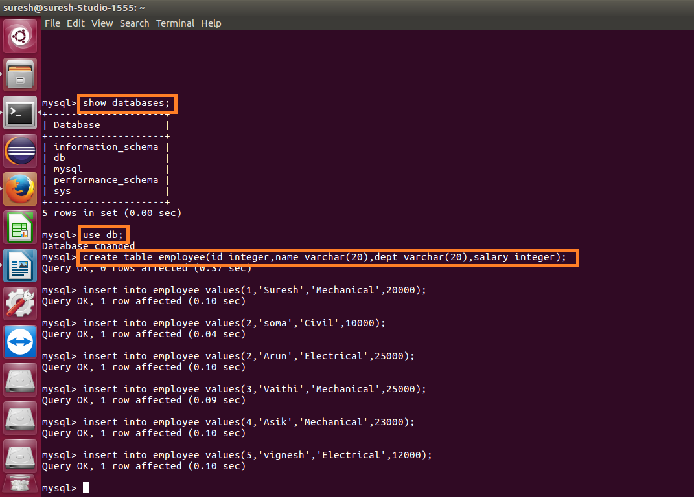

Displaying the contents of the table:

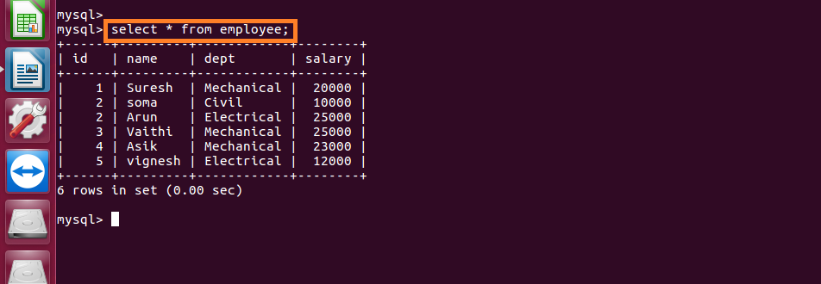

Importing the data from mysql to hdfs :

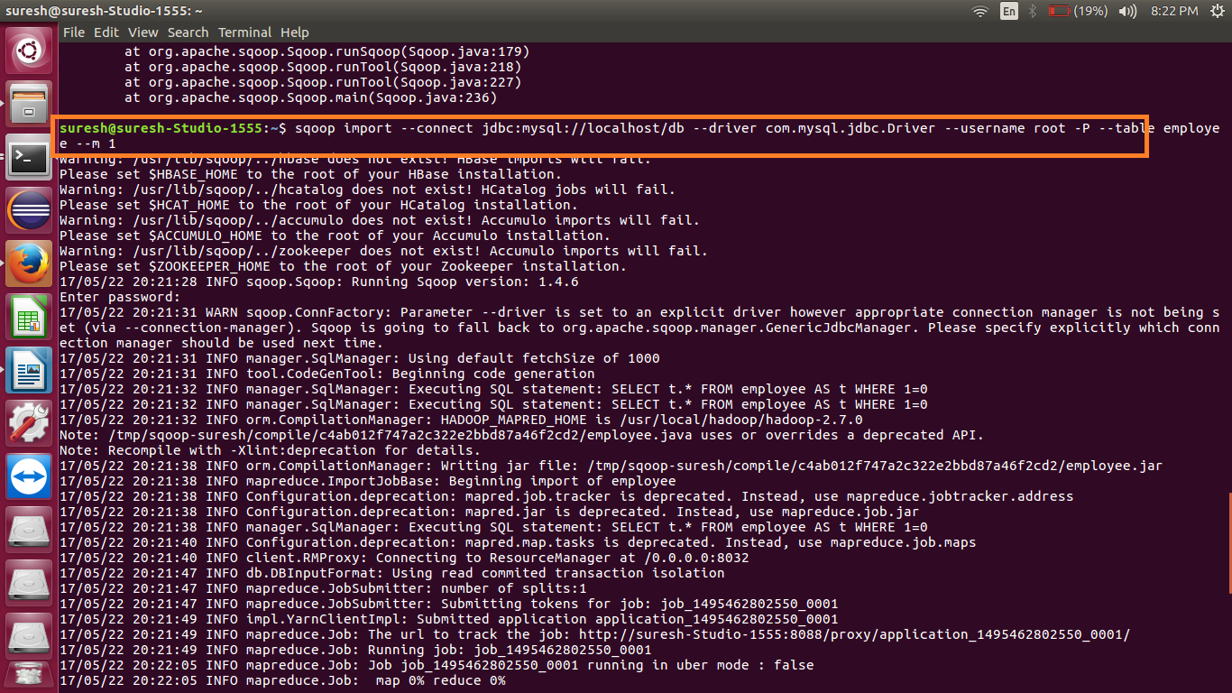

Data successfully imported:

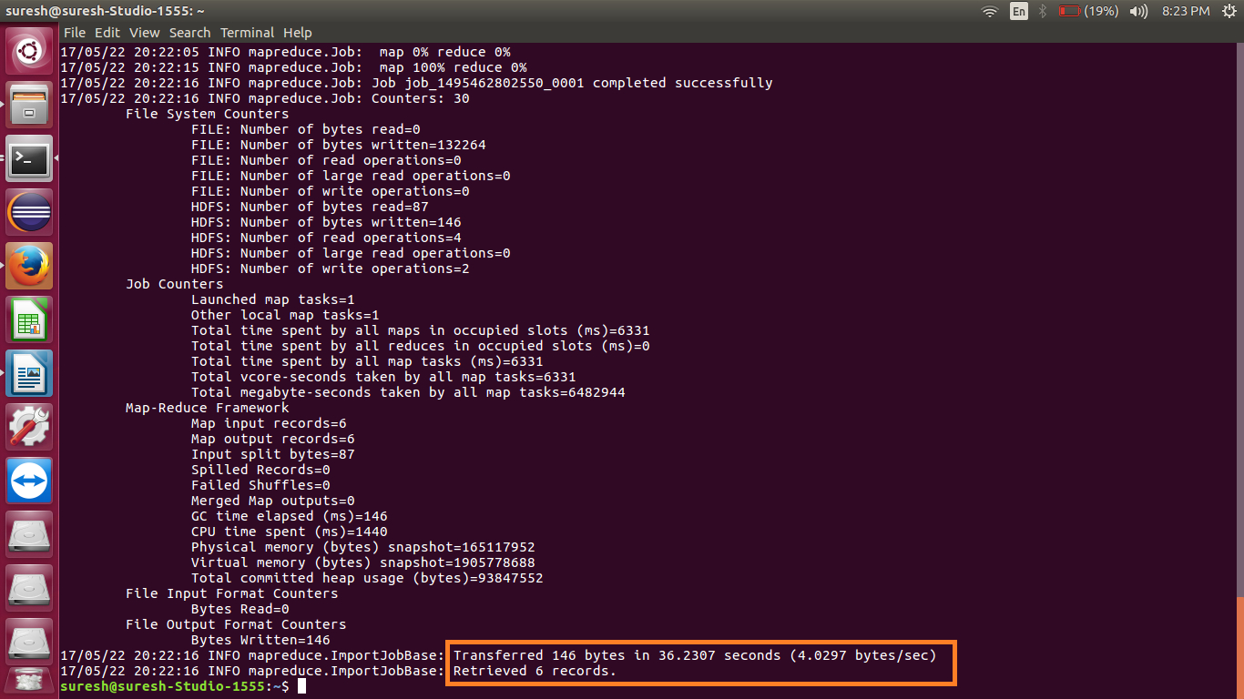

Checking whether the files are imported and displaying the contents of the employee.

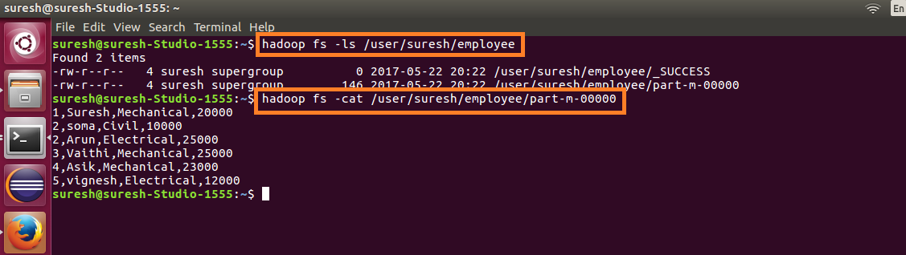

Creating a new table employee2 and leaving it empty as the exported data from hdfs will be stored here

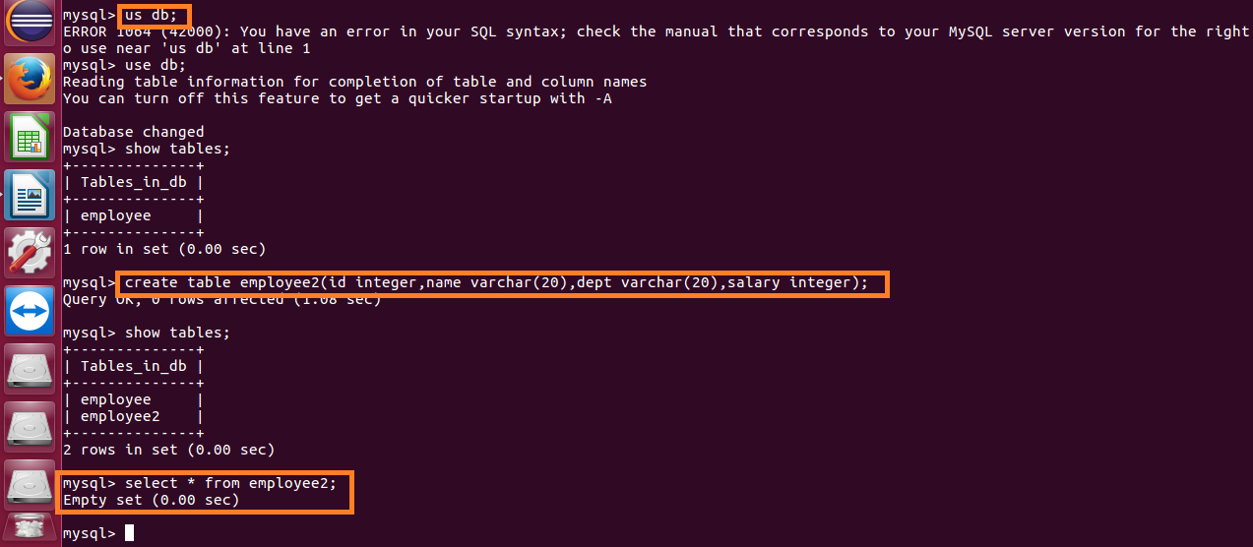

Exporting the data from hdfs to mysql:

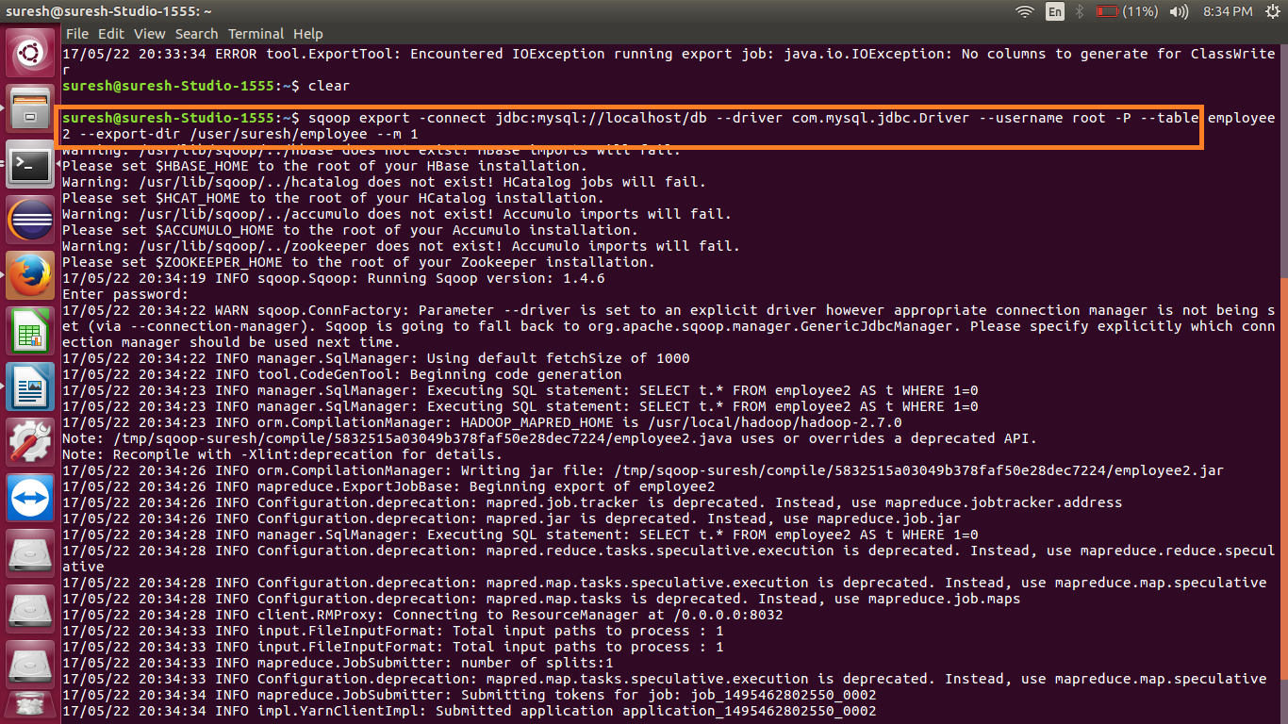

Data successfully exported:

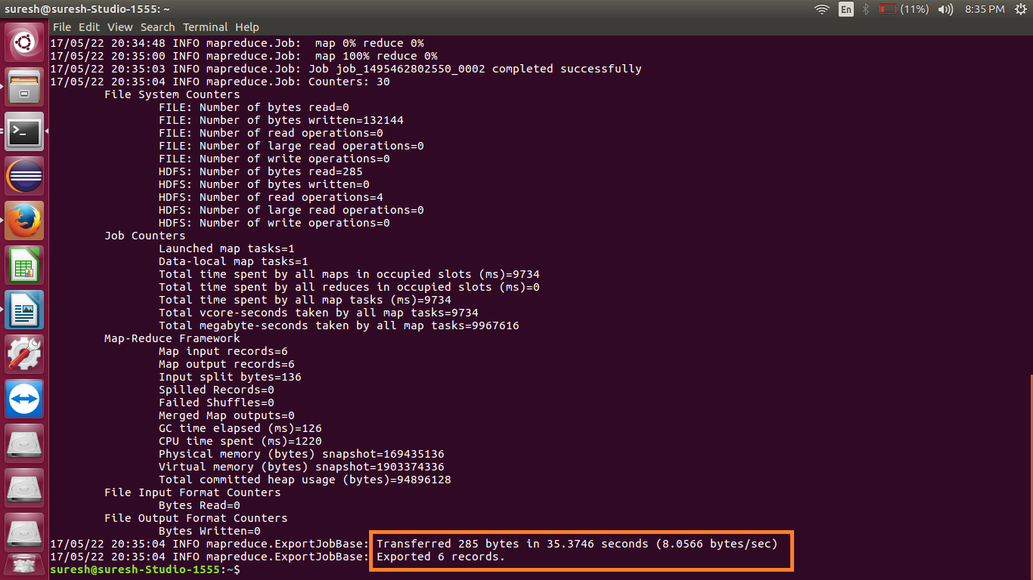

Displaying the contents of the exported table:

